Audiology Request
Patient Name: DOB: / /
Phone: Email:
 | CUSTOM EAR MOULDS  ☐ Water Excluding Plugs  ☐ Noise Excluding Plugs  ☐ Musicians Filtered Plugs  ☐ Australian Standard 1269.4-2014/ Commercial Drivers Licence / CASA | PAEDIATRIC ASSESSMENT  ☐ Hearing Assessment  VESTIBULAR ASSESSMENT  ☐ VNG / Calorics  ☐ vHIT (Video Head Impulse Test)
 | ADULT ASSESSMENT  ☐ Employment Assessment  ☐ Hearing Assessment  ☐ Hearing Aid Suitability Evaluation  ☐ Tinnitus Rehabilitation & Management  ☐ Cochlear Implant Candidacy Assessment | ADULT REHABILITATION  ☐ Hearing Aid Adjustment  ☐ Hearing Services Program (HSP) For eligible pensioners and veterans  ☐ Cochlear Implant Mapping  ☐ Bone Conduction Implant Adjustment
 | ELECTROPHYSIOLOGICAL ASSESSMENT  ☐ Auditory Brainstem Response (ABR)  ☐ Electrocochleography (EChoG)  ☐ Vestibular Evoked Myogenic Potentials (VEMPs) | 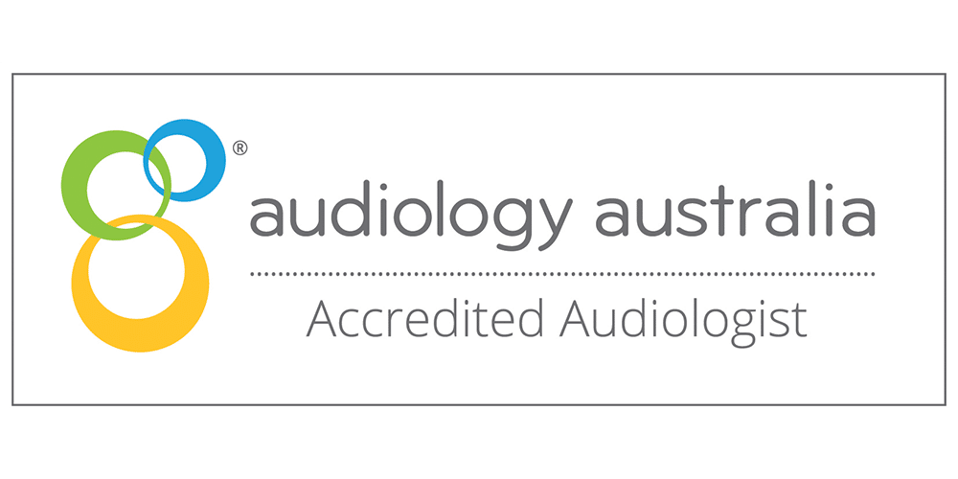
 | Principal Audiologists
Philippa Carter  Audiologist, MAudSA (CC) |  |  | Matthew Del Favero  Audiologist, MAudSA (CC)
Referral Investigation:
Referral Source:
Provider Number: Date:

